ECA5701-NANOELECTRONICS C01-2
S.RUPIKA
192512398
EXPERIMENT 2
Exp. 2. Simulation of Density of States of Quantum Well Structure with Various Nanometer Thickness.
Aim: To simulate density of states of quantum well structure with various nano meter thickness.
Case Study 1: Simulate the density of states of quantum well of thickness 0.5 nm
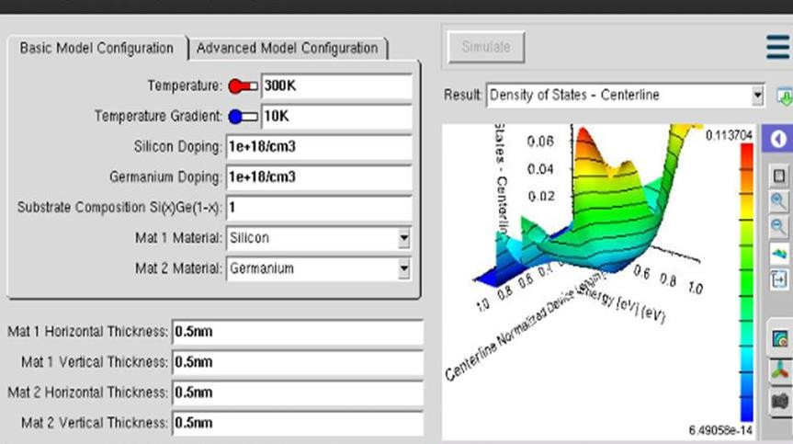
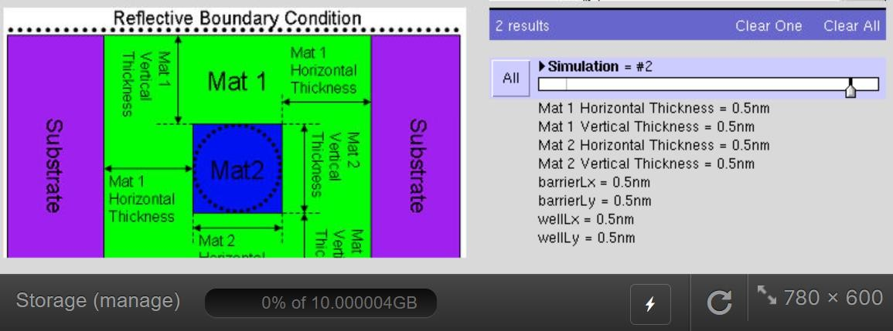

Case Study 2: Simulate the density of states of quantum well of thickness 0.6 nm


